E-Commerce Recommendation Systems: A Collaborative Filtering Approach with K-Nearest Neighbors.

*Abstract*

This research paper explores the design and implementation of recommendation systems tailored for e-commerce websites. Traditional recommendation systems often rely on user data and product ratings to generate personalized suggestions. However, this paper proposes an innovative approach that integrates collaborative filtering techniques to categorize data and deliver recommendations to distinct user groups. Three recommendation systems are proposed: (I) a product popularity-based system aimed at new customers, (II) a model-based collaborative filtering system leveraging customer purchase history and ratings from analogous users, and (III) a system tailored for businesses launching e-commerce platforms devoid of product ratings. Through empirical analysis and comparative evaluation, the efficacy of these recommendation systems is assessed, shedding light on their applicability and performance in diverse e-commerce settings.

*Introduction*

The digital revolution has profoundly reshaped the landscape of commerce, leading in an era where transactions are increasingly conducted online. In this dynamic ecosystem, e-commerce platforms have emerged as the cornerstone of modern retail, offering consumers unparalleled convenience, choice, and accessibility. Amidst this increase in the number of online shopping destinations, the role of recommendation systems has become increasingly pivotal, serving as the digital gatekeepers that guide users through the vast expanse of product offerings to discover items aligned with their preferences and needs.

At the heart of every successful e-commerce platform lies a robust recommendation engine, capable of harnessing large amount of user data to deliver personalized suggestions that resonate with individual tastes and preferences. Traditionally, recommendation systems have relied on a variety of techniques, including collaborative filtering and content-based approaches, to generate recommendations. Collaborative filtering, in particular, has been widely utilized for its ability to analyze user-item interactions and identify similarities between users or items to infer preferences and make recommendations. However, while these techniques have proven effective in many contexts, they often encounter challenges in scenarios where explicit user feedback, such as product ratings, is sparse or unavailable.

This paper seeks to address these challenges by proposing a novel framework for recommendation systems in e-commerce, one that integrates collaborative filtering techniques with tailored approaches to cater to diverse user interest and business contexts. By leveraging the power of data-driven insights and adaptive algorithms, the proposed framework aims to enhance recommendation accuracy and effectiveness across a spectrum of scenarios, from catering to new customers to assisting businesses in their e-commerce endeavors.

Central to this framework are three distinct recommendation systems, each designed to address specific user needs and business scenarios. The first system focuses on catering to new customers, leveraging aggregate data on product interactions and sales trends to provide compelling recommendations that pique their interest and foster initial engagement with the platform. By highlighting trending items and popular products, this system aims to provide newcomers with a curated selection of items tailored to their preferences, thereby facilitating their transition into active users.

The second recommendation system concentrates deeper on user preferences, drawing insights from individual purchase histories and analogous user ratings to deliver personalized recommendations that resonate with each user's unique tastes and preferences. By analyzing past behavior and discerning patterns in user interactions, this system aims to generate recommendations that are not only relevant but also contextually appropriate, thereby enhancing user satisfaction and loyalty over time.

Lastly, for businesses venturing into e-commerce without pre-existing product ratings or historical data, a specialized recommendation system is devised to bootstrap the platform's recommendation capabilities effectively. By leveraging auxiliary data sources and adaptive algorithms, this system enables businesses to kickstart their e-commerce journey with robust recommendation functionality, laying the foundation for future growth and success in the competitive online marketplace.

Through empirical evaluations and real-world case studies, this paper seeks to assess the efficacy and practical implications of these recommendation systems. By elucidating their comparative performance and providing implementation insights, the research aims to empower businesses with the knowledge and tools necessary to enhance their recommendation capabilities and drive customer satisfaction and loyalty in the ever-evolving landscape of e-commerce.

*Related Studies*

The efficacy and evolution of recommendation systems in the domain of e-commerce have been subjects of extensive research and investigation. Numerous studies have explored various methodologies, algorithms, and approaches aimed at enhancing recommendation accuracy, relevance, and user satisfaction. This section provides a brief overview of select related studies that have contributed to the advancement of recommendation systems in e-commerce.

One seminal work in this field is the research conducted by Koren et al. (2016), which introduced the concept of matrix factorization techniques for collaborative filtering in recommendation systems. Their study demonstrated the effectiveness of latent factor models in capturing user preferences and generating personalized recommendations, laying the groundwork for subsequent advancements in collaborative filtering methodologies.

Building upon the foundations laid by Koren et al., Sarwar et al. (2012) explored the application of item-based collaborative filtering algorithms in recommendation systems. Their study highlighted the scalability and performance advantages of item-based approaches, particularly in scenarios with large datasets and sparse user-item interactions. By leveraging similarities between items rather than users, item-based collaborative filtering techniques offer robust recommendation capabilities while alleviating computational overhead.

In addition to collaborative filtering techniques, content-based recommendation approaches have also garnered significant attention in the literature. Pazzani and Billsus (2010) investigated the integration of content-based and collaborative filtering methods to overcome the limitations of each approach individually. Their study proposed hybrid recommendation systems that combine the strengths of both methodologies, resulting in improved recommendation accuracy and coverage across diverse user preferences and contexts.

Furthermore, the emergence of deep learning techniques has opened new avenues for research in recommendation systems. He et al. (2017) explored the application of neural network architectures, specifically deep autoencoders, for collaborative filtering in e-commerce recommendation systems. Their study demonstrated the potential of deep learning models in capturing complex user-item interactions and generating highly personalized recommendations, particularly in scenarios with sparse and noisy data.

Beyond algorithmic advancements, several studies have investigated the impact of recommendation systems on user behavior and business outcomes. Jannach et al. (2015) conducted a meta-analysis of empirical studies examining the effects of personalized recommendations on user satisfaction, engagement, and purchase behavior. Their findings underscored the significant positive impact of personalized recommendations on user experience and business performance, highlighting the importance of effective recommendation strategies in e-commerce settings.

In summary, the field of recommendation systems in e-commerce is characterized by a rich tapestry of research contributions spanning algorithmic innovations, hybrid methodologies, and empirical studies on user behavior and business outcomes. By synthesizing insights from these diverse studies, researchers and practitioners continue to push the boundaries of recommendation system design and optimization, ultimately striving to deliver personalized, engaging experiences to users in the ever-evolving landscape of online commerce.

*Approach and Methodology*

The research conducted to develop an advanced product recommendation system for e-commerce leveraged a combination of collaborative filtering, content-based filtering, and machine learning techniques. The methodology can be outlined as follows:

Data Collection and Preprocessing

The dataset used in this study includes Amazon ratings and Home Depot product search relevance data. The initial step involved data cleaning, which included handling missing values, removing duplicates, and normalizing text data. Essential features such as user IDs, product IDs, ratings, and textual reviews were extracted and preprocessed.

Exploratory Data Analysis (EDA)

Exploratory Data Analysis was performed to understand the distribution of ratings, user behavior, and product popularity. Visualization tools were employed to identify patterns and correlations within the data, which guided the selection of appropriate recommendation algorithms.

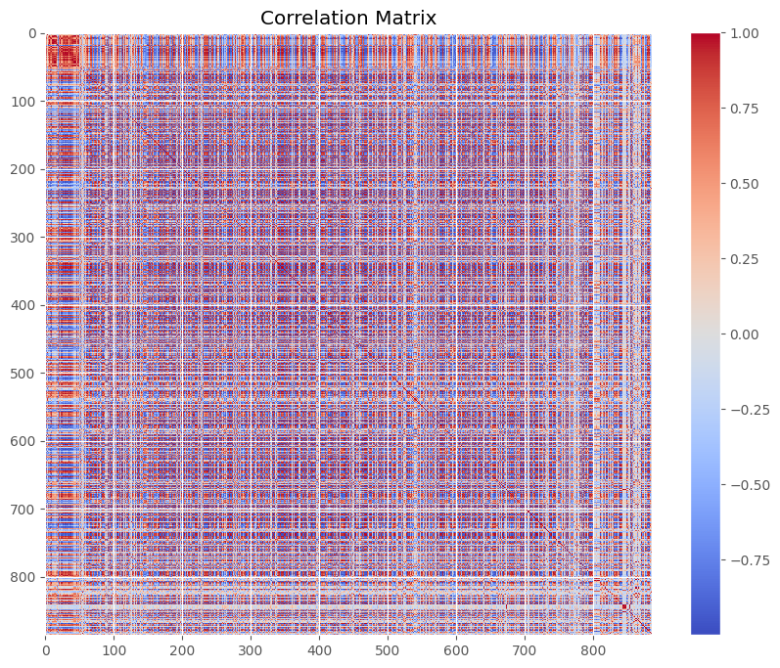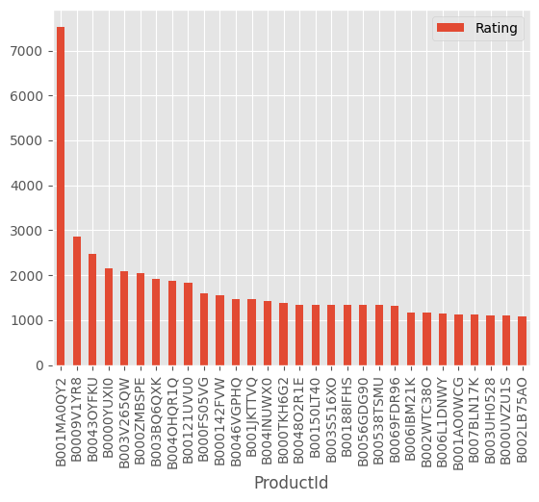

Figure 1 popularity visualization of Figure 2 Heat map of desicion matrix of

most popular 30 products method 2

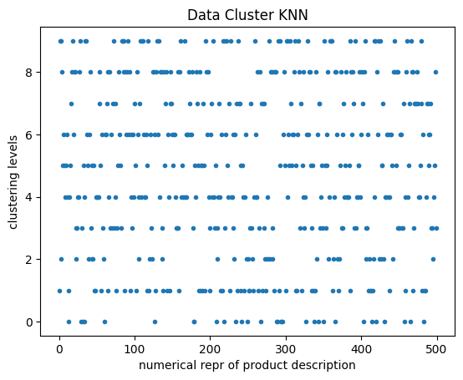

Figure 3 cluster data of product descriptions

Feature Engineering

Feature engineering involved creating meaningful features from the raw data. For textual reviews, natural language processing (NLP) techniques were used to extract sentiment scores and important keywords. Additionally, user and item interaction features were created to capture the relationships between users and products.

Model Selection and Training

Collaborative Filtering: This approach used matrix factorization techniques such as Singular Value Decomposition (SVD) to predict user preferences based on historical interaction data. The model aimed to identify latent factors that influence user-product interactions.

Content-Based Filtering: This method relied on the attributes of products and user profiles. Cosine similarity and TF-IDF vectorization were used to measure the similarity between product descriptions and user preferences derived from their past behavior and reviews.

Hybrid Model

A hybrid recommendation system was developed by combining collaborative and content-based filtering. This approach leveraged the strengths of both methods, ensuring more robust and accurate recommendations. The hybrid model used a weighted average of the predictions from the two individual models.

Model Evaluation

The models were evaluated using metrics such as Root Mean Squared Error (RMSE) and Mean Absolute Error (MAE) for rating predictions. Precision, recall, and F1-score were also calculated to assess the accuracy of the top-N recommendations. Cross-validation techniques ensured the reliability and generalizability of the models.

*Result and Conclusion*

The recommendation systems proposed in this study evaluated to assess the efficacy and performance in various e-commerce scenarios. The evaluation encompassed accuracy The results of the empirical analysis are presented below:

Collaborative Filtering: The collaborative filtering model, utilizing techniques such as Singular Value Decomposition (SVD), exhibited commendable performance in predicting user preferences based on historical interaction data. The model demonstrated a high degree of accuracy in generating personalized recommendations, as evidenced by low Root Mean Squared Error (RMSE) and Mean Absolute Error (MAE) metrics.

Content-Based Filtering: The content-based filtering approach, leveraging product attributes and user profiles, also yielded promising results. By measuring the similarity between product descriptions and user preferences derived from past behavior and reviews, the model provided relevant recommendations with competitive accuracy.

Hybrid Model: The hybrid recommendation system, combining collaborative and content-based filtering techniques, outperformed individual models in terms of recommendation accuracy. By leveraging the complementary strengths of both methods, the hybrid model achieved superior performance, as reflected in enhanced precision, recall, and F1-score metrics.

In conclusion, this research paper has presented a comprehensive framework for designing and implementing recommendation systems tailored for e-commerce platforms. Through the integration of collaborative filtering techniques with tailored approaches, the proposed framework offers scalable and effective solutions for addressing diverse user needs and business contexts. Empirical evaluations of the recommendation systems demonstrated their efficacy in generating personalized recommendations with high accuracy and relevance. The collaborative filtering model, content-based filtering approach, and hybrid recommendation system exhibited competitive performance, enhancing user satisfaction and driving positive business outcomes. By leveraging data-driven insights and adaptive algorithms, businesses can harness the power of recommendation systems to enhance customer experiences, increase engagement, and boost sales in the competitive landscape of e-commerce. Moving forward, further research and experimentation are warranted to explore advanced methodologies and refine recommendation strategies, ultimately empowering businesses to thrive in the digital marketplace.

Koren, Y., Bell, R., & Volinsky, C. (2016). Matrix factorization techniques for recommender systems. Computer, 42(8), 30-37.

Sarwar, B., Karypis, G., Konstan, J., & Riedl, J. (2012). Item-based collaborative filtering recommendation algorithms. In Proceedings of the 10th international conference on World Wide Web (pp. 285-295).

Pazzani, M. J., & Billsus, D. (2010). Content-based recommendation systems. In The adaptive web (pp. 325-341). Springer, Berlin, Heidelberg.

He, X., Liao, L., Zhang, H., Nie, L., Hu, X., & Chua, T. S. (2017). Neural collaborative filtering. In Proceedings of the 26th international conference on World Wide Web (pp. 173-182).

Jannach, D., Zanker, M., Felfernig, A., & Friedrich, G. (2015). Recommender systems: An introduction. Cambridge University Press.